

Completion Report on
Student Development Program
conducted for
College Name
covering
Track Name
For the year 2024-25

Implemented by:
EDUNET FOUNDATION

Sponsored by:
MICROSOFT CORPORATION INDIA PVT LTD
&
SAP INDIA PVT LTD

TechSaksham Track Session
The TechSaksham SDP sessions were conducted from start date to end date. The session was conducted on Track Full name (abbreviation). The sessions were managed by Trainer Name from the Edunet Foundation.
Completed Training Hours:
Topics Covered:
Number of enrolled students in LMS:
Number of active students in LMS (attendance>=60%):

Session Photographs
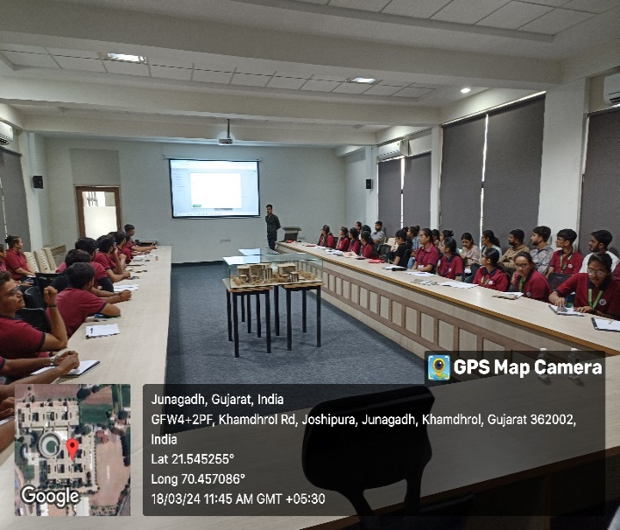 | 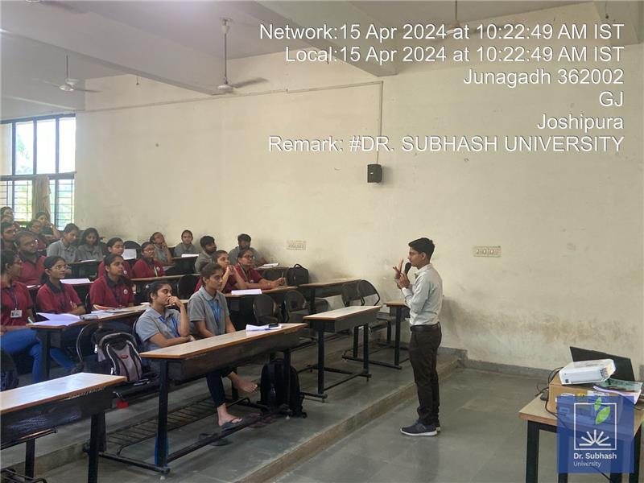

Assessments Analysis

Cumulative Analysis results from mid-term assessments, final-term assessments, and project evaluations to provide a holistic view of students' performance and achievement throughout the program.

Description | Mid Term | Final Term | Project
Total number of submissions
Maximum Marks obtained | 30 | 40 | 30
Highest Score
Minimum Score
Average Score

Highlight of best Projects submitted from the batch

Number of Group Project Submissions:

Best Project 1: Title of the Project
Student Name : Email Id | Student Name : Email Id
Student Name : Email Id | Student Name : Email Id

Add Abstract of Project | Snap of Project Output

Best Project 2: Title of the Project
Student Name : Email Id | Student Name : Email Id
Student Name : Email Id | Student Name : Email Id

Add Abstract of Project | Snap of Project Output

Other highlights of the batch

Students completed a self-paced certification, demonstrating their commitment to independent learning and skill development. This approach allowed them to achieve certification at their own pace, reflecting their dedication and mastery of the subject matter.

Number of self-paced courses completed by students:

Certificates Snippets
 | 

Summary of TechSaksham Program
This data highlights the participation and achievements of students in a program, indicating enrollment numbers, certification eligibility, project submissions, and internship placements. these metrics not only quantify participation but also provide a measure of success and engagement within the program. They demonstrate both the breadth of involvement among students and the tangible outcomes they achieve.

Number of Enrolled Students | 60
Number of Students qualified for Completion Certificates | 36
Number of Students qualified for Participation Certificates | 10

